

**ACTIONAID -GAKA PROJECT REPORT by Gaka Fm 96.5**

**SOCIAL ACCOUNTABILITY PROJECT**

**INTRODUCTION**

The social accountability project has become a weapon to fight corruption and malpractices in development efforts In Mlolo and Mbenje Traditional Authorities. The office bearers have been taken to task by community members through rac representatives on discrepancies surrounding development projects. There have been instances where substandard structures have been elected where lots of money have been spent. The community have suffered for been given row deal by office bearers. This has created mis- trust on the side of community members who have poor service delivery systems at the end of the day.AS of 31/10/2018 Gaka FM with support from Action Aid 5 Live Debates, 4 public Hearing and 2 radio talk shows have been conducted. The target groups have been Alfazema, Chitseko and Namanya racs in Mlolo and 2 Studio Talk shows have been conducted.. The main issues pursued in the targeted areas have been lack of transparency and accountability on agriculture related projects at Alfazema, success story of Chitseko rac in the fight against non-transparency and accountability, unfinished project at Makhapha irrigation scheme and Milore dike construction. In all these places elements of lack of transparency and accountability are vivid manifestations of the process.

This process has a revolutionary element which is a bitter juice to swallow by the office bearers but for community members this is no retreat and no surrender journey. Community leadership salutes Action Aid and Gaka FM for light given to them which enables them to see the hidden evils of their societies..

Social Accountability project has also revealed hidden dubious styles of those who abuse power and office by stealing from the poor and voiceless community members. The racs and community members are now able to track project budgets allocated to different projects within their areas. The office bearers are working under pressure because they know citizen eye is watching them. It will be very difficult for them to hide whatever is happening due to technical support they are getting from Action Aid and Gaka Radio. The highlighted issues like Wash Room /Change Room at Chilimba School, Nyamalikombe Bridge, Toilets at Bangula New and Old Markets, Garden Shelter at Sorgin Health Centre, irrigation scheme at Makhapha in Traditional Authority Mlolo, Namiyala Primary School Brick Making and Swally Construction Project, have provoked a lot of debate in communities and these revelations have put more pressure of office bearers. Things are never the same.

**ACTIVITY FOCUS AREAS**

The Social Accountability Project with funding from Action Aid has implemented 7 out of 15 studio talk shows 3 out of 5 Live 0broadcasting debates 4 out of 7 Public hearing for the period of October to November 2018

* The menstrual cycle for female pupils has triggered absenteeism during Wash Room at Kalupsya where beneficiaries feel the service rendered was not worthy for most of the girls due to lack of menstrual hygiene in most schools. Chilimba Primary School was privileged to be given funds for a Wash Room to address absenteeism problem especially among girls. This could improve sanitation, and promote quality girls education. This is supposed to benefit female students especially when they want to clean themselves and change clothes during menstruation period. The Wash room in question has been constructed using substandard materials which will not last long and not conducive for the intended purpose. If funds are available , there is need to engage the PEA, and the District Education Manager
* Mbenje teacher’s house was moving at a slow pace because the money for the construction was borrowed by the head teacher and the school committee chair. After engagement of the authorities the money was given back and the contract has been completed
* The Makhapha solar Irrigation scheme is not completed where LDF funds were being used. This has raised eyebrows from community members who feel that the funds have been abused. The Leadership (GVH Chapinga) has no knowledge as to what has made the project not to be completed. This issue is still outstanding due to lack of funds to engage the Mlolo ADC and the district authorities. Chapinga Rac seems to have little knowledge on how to follow issues in their area. There is need to train this Rac in order for them to have capacity to deal with issues of social accountability in their area. There is need to engage the ADC, Contractor, and the district council in order to see the way forward.
* The Dike at Masenjere which was constructed to protect Masenjere Health Centre at the tune of 290,000,000 was viewed to be a substandard structure from a practical point of view. This could not be verified by Dike experts. The people felt that fishy business took place during the time of construction where cement and other construction materials were being sold to the locals. This was not taken to higher steps (meeting the ADC,, MP , contractor and the district council )because of lack of funds.
* The Nyamalikombe Bridge has been constructed with substandard materials where beneficiaries feel there is no value for money. During this time of the year parents feel that their children are not secured especially when they are going/coming from school. Children from GVH Ntchenyera to Bangula Primary School cross Nyamalikombe River. This is a risky bridge and beneficiaries are taking office bearers to task knowing that Constituency development funds were used to address problems of access to education and other social amenities. The parliamentarian of the areas is the one who initiated the project with little or no consultation with local committees. The project need to engage the MP, and the district council
* The constructed toilets (2) at Bangula Old and New Markets are of substandard which have not been handed over to the community for use. Already one of the toilets at the new Bangula market has shown signs of collapsing. According to the Chair of Nsanje district Assembly the money was from Local Development Fund. This issue has a negative effect on the market community because sanitation being compromised. People are using the bush when responding to call of nature. After engaging the Ward Counsellor of the area it was agreed that toilet handover has to be done where maintenance has to be done to the structures which have clacks. With the onset of the rains there is high probability that people using the market may get water borne related diseases

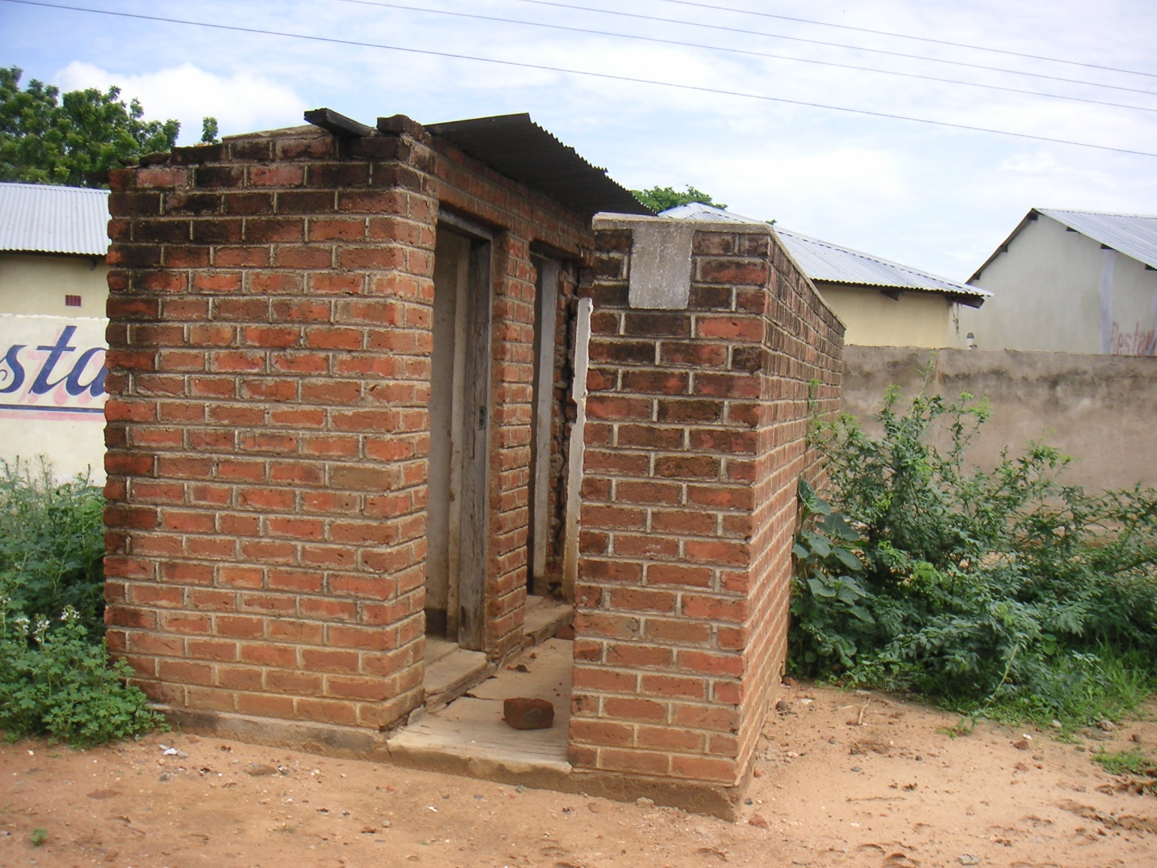

One of the toilets at New Bangula Market (not yet handed over to market users)

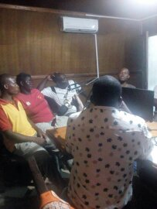

The Councillor , Rac and ADC members during one of studio talk shows

* Sorgin guardian shelter at Sorgin was completed with dissatisfaction of the community because of type of windows, glasses fixed. The Nsanje District Assembly Chair, it was resolved that the contractor fix the windows and glasses as stipulated in the contract agreement.

These issues (Wash Room and Nyamalikombe Bridge) have been discussed at Traditional Authority level and it is believed that office bearers shall be more accountable on projects which are eye marked for the targeted communities.

* Makolokoto Youth Organisation expressed their disappointment on how development issues are being handled especially when it comes to implementation and financing where youth are sidelined. As youth and young leaders they are calling for transparency and accountability in order to achieve genuine and sustainable development.
* The office bearers concerned are people of influence in the society like head teachers Councillor and members of parliament. The community members are now ready to follow any development funding aimed at improving the livelihood system of their households and community at large.

**Implementation Information**

|  |  |
| --- | --- |
| 1. **Name of Project:** | 1. **Traditional Authorities** |
| Community social accountability | Mbenje/ Mlolo |

|  |  |  |
| --- | --- | --- |
| 1. **Project Site:** | 1. **Issue under discussion** | **Parties involved** |
| GVH Alfazema | Swalley construction /beneficiary identification | Alfazema rac, community members |
| GVH Chitseko | Successful completion of Namiyala school block | Chitseko rack and community members |
| GVH Namanya |  | Namanya rac and extension workers |
| GVH Chapinga | Makhapha irrigation scheme/unfinished | Chapinga rac and extension workers |
| 1. Project Site: | 1. Issue under discussion | Parties involved |
| Chilimba School | Wash/Change Room/ substandard materials/ value for money | Head Teacher versus School Committee/rac |
| Nyamalikombe Bridge | Substandard Materials | Member of Parliament versus ADC and Youth |
| Bangula New Market and Old Market | Substandard toilets and no handover one year after completion | Counsellor, market users, DC,TA, Market Chair, (Bangula New Market) |
| Sorgin Health Centre | Guardian Shelter | Counsellor, MP, Beneficiaries, Contractors |

|  |  |  |  |
| --- | --- | --- | --- |
| **Date** | **Thematic Area** | **Target** | **Interviewees** |
| 02/10/18 | Live Debate | GVH Alufazema | Piason Madomba,Joseph Tembenuka,Samson Ctchereni,Rojas Fraction,Khrise Chinkango,Agnes Malema,Magrete Alfonso,Estere Samson,Loyidi Thebo,Laston Chimwaza, |
| 09/10/18 | Radio talk shows | Mbenje rac | Chrisy Francis,Lidiya Mtenuwa,Melina francis,Nyalani Mpakula, Sebastiano Jeke, Tinasoni Maya,Mybeck Master |
| 10/010/18 | Public hearing | Namanya Rac | Beneficiary Identification |
| 12?10/18 | Radio talk shows | Namanya Rac | Patrick Jeke, Dolofe Kalonga,Maliya Goche,Felix Ntaibu,Fredson Falch, Tobias Msongwe,Sandeson Bodza,Lingiston Bodza,John Andifolo,Maria Solomoni |
| 19/01018 | Live debate | GVH chapinga | Selina Alufandika,Anne Mzava,Elita Stenala,Mercy Zalimba,Ethel Maenje,Lines Sabe,Alexious Akayanjana,Ernest Galafa,Florence Mangathayo, |
| 23/10/18 | Public Hearing | Magoti EPA – Mbenje ADC | Radick Semba,Maxwel Jonathan,Stella Davie,Fabiano Mkwakwasi Emanuel Nkhodolo,Letasi Ngoma,Mcphillip Walter,Luciano Kumpanyira,MalyShaya, Fraction Wiseman,Peter Ganizani,Keneth Kusemba,Tinason Maya,Zatha June,KefasiCtchalieEdward BandaStephen PhadovuGodfry Mizedya,Maliani Jeremani,James Mwandile,Joachim Mperekwa,Charity Dzongwe,Mcpherson Magaso,Gift Machilika,Martha Phiri,Joseph Peter,Suzana Bande,Samson Chuku,Handriet Membala,Solomoni Silo |
| 24/10/18 | Public hearing | Chitseko rac | Beneficiary identification |
| 26/10/18 | Public Hearing | Chitseko | Mathews Piano,Joshua Lozani,Nego Njanji,Christina Tobiasi,Patricia Mashawa,Dinesi Maguza, Wilson Fulukiya, Petro Zuze,Anderson Kenala,Ndaziona zguta, Peter Zuze,Sarah Mpata,Selena Hajan,Henry GocheOsman Fatch |
| 26/10/18 | Live debate | Namanya | Issac Mussalilian Gundani,Luka Yobe,Chrisy Benford, Tereza Josa,Josophine SankondeEliza Lusiyano,Jake Mponda,Umisi TauloMuwnga Watson,Raphael Joseph, Safila Hamuza,Ted Fatych |

|  |  |  |  |
| --- | --- | --- | --- |
| Date | Thematic Area | Target | Interviewees |
| 01/11/2018 | Studio talk shows | ADC  Mbenje | Stera Davie ,Maxwell Jonathan, Radick Semba, Mcphillip Water, Hussen Jaffari,Peter Ganizanio, Edward Banda, |
| 05/11/2018 | Studio talk shows | Nnembe rac, ADC | Radick Semba, Mavuto Kamba,Mariko Feckson, Tonex Dayo,Maxwell Jponathan , Jeniffer Jussa, Beatrice Nyimbiri, |
| 11/11/2018 | Studio talk shows | Youth Tambo VDC | Agnes Dyton, John Mdedza, Dolika Zanditha, Yohane Saizi, Rafred Vagi,Mussa Fatchi, Magret Nkosi |
| 22/11/2018 | Studio talk shows | Counsellors, T/A, ADC Members | T/A Mbenje ,Stera Davie, Mavuto Kamba, McPhillip Water, Hussein Jaffari ,Edward Banda, Zaidu Atima |

|  |
| --- |
| **PROGRAMME FEEDBACKS**  Gaka fm got programme feedback through   1. Citizen Hour Program 2. ADC meetings 3. Phone in programmes 4. Request to rebroadcast some social accountability programmes 5. Comments on the broadcasted programs |

|  |
| --- |
| **PROCESSES** |

Need identification with the racs in consultation meetings in their respective areas

Engagement with the office bearers and contractors where problems are affecting them either as people who can provide oversight or people who are involved in scrupulous business

Consultation with area leadership/ADC, Councillors/ PEA whether they know the gaps or they are involve in the creation of gaps and processes

Engagement of district officials: All tackled issues have not yet been concluded because of unavailability of funds.

|  |  |  |  |  |  |  |  |  |  |  |  |  |  |  |  |  |
| --- | --- | --- | --- | --- | --- | --- | --- | --- | --- | --- | --- | --- | --- | --- | --- | --- |
| *Gaka fm 96.5 used the following strategies*   |  |  |  |  | | --- | --- | --- | --- | | *Activity* | *Total planned* | *Total achieved* | *balance* | | *Studio Talk Shows* | *15* | *7* | *8* | | *Live Broadcasting debates* | *5* | *3* | *2* | | *Public Hearing* | *7* | *4* | *3* | |

|  |
| --- |
| **LESSON LEANT** |
| 1. Process of enlightment has started. 2. Office bearers have started to realise the power of the people 3. The local leaders are also taking part in corruption practices 4. A lot of community members are aware of corrupt practices   **CHALLENGES;**   1. Postponement of schedules due to excuses by office bearers. 2. Some office bearers are being shielded by “ royal’’ community member 3. Office bearers not willing to discuss issues about transparency and accountability 4. The budget was small to cater for the project needs   **CONCLUSION**  Time has come when every development activities as long as it affect the lives of the people shall be transparent and those who will abuse power shall be put to shame or face the law. The motivated communities who are trying to get to the bottom of issues in communities are here to stay. With the involvement of the youth in this project, expectations are high that one day our society shall manage to have transparent and accountable office bearers with responsible citizens.  The project has triggered a lot of desire even outside catchment area to air their stories of corruption and no compliance to social delivery services, It is also our hope that this project extends to other places and make tangible impact for the benefit of the voiceless. |

**Chitseko rac:**

**Namiyala School and feeding Centre goods**

Namiyala School Management and staff arranged that the sorounding villages like Chitseko, Tchatacha, Nyaikha, Gundani, Moloseni ,Sandram and Chambuluka to contribute money for brick moulding for school blocks since the original was washed away by the diverted Ruo river. After some 5 months of silence and nothing was happening on the ground ,Chitseko Rac engaged the school management to explain what was happening and why the silence. It was revealed that the parliamentarian of the area had also pledged to help with CDF and this money was not realised yet . This prompted the Rac to meet the MP and when they did not get satisfactory answer they went to meet the DC who assured them that funds were to be released after consultation with the Parliamentarian of the area. Funding was done after a month and school management at Namiyala School released the contributed funds for the moulding of bricks.

Chitseko Rac , so powerful , so passionate and patriotic for their area. No organisation can operate within GVH Chitseko without the blessings of Chitseko Rac.

**Mbenje rac:**

**Teachers house at Mbenje School**

Mbenje School Management committee were not transparent enough as to how SIP funds were being used in the construction of one of the teacher’s houses. This took th courage of Mbenje Rac to make sure things are not out of hand. The Rac summoned a meeting organised by Gaka where They demanded accountability of the SIP funds. It was revealed that some of the funds were borrowed by the head teacher and the Chair of the committee. During this meeting there were tension between the Head teacher and the other school committee members who were regarded as traitors. It was finally agreed that the funds be returned within two weeks failing which will lead to legal action.

The money was given back as demanded by the Rac and the contract has been completed.